

***Dism Project Documentation***

**Faculty**: **Shaikh Faizan Hasan**

**Group Members:**

Abdul Rehman ( 1413839 )

M. Huzaifa Khan (1412999 )

Abdul Rehman ( 1413030 )

**ADD CATEGORY:**

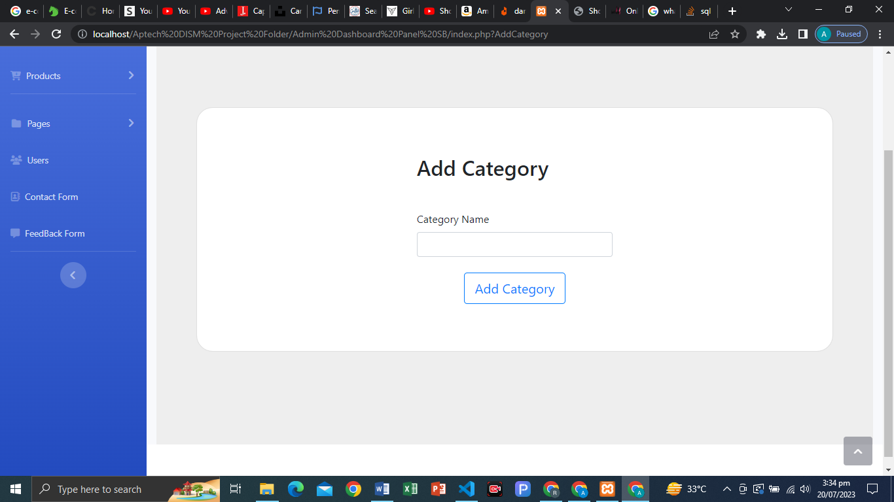

**STRUCTURE CODING:**

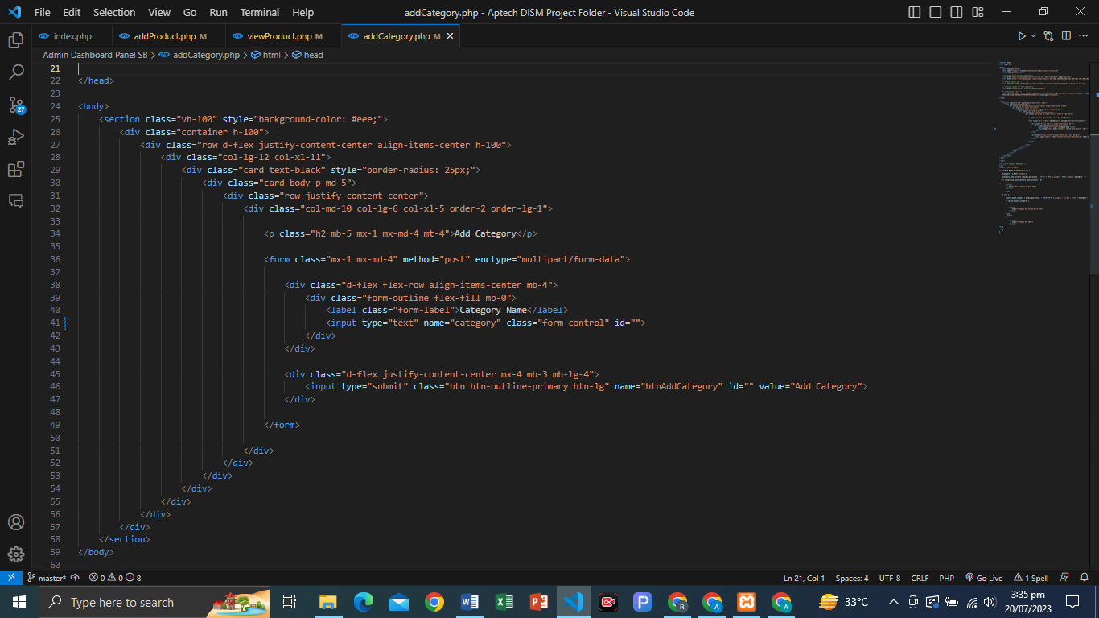

**PHP CODE ADD CATEGORY…!**

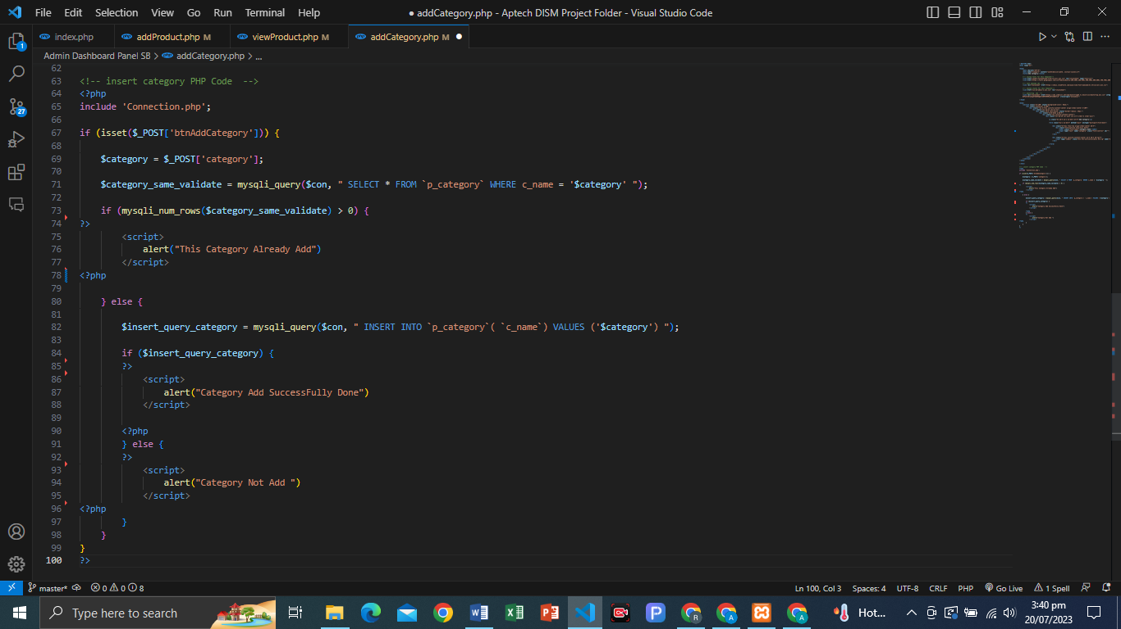

MY SQL CATEGORY TABLE:

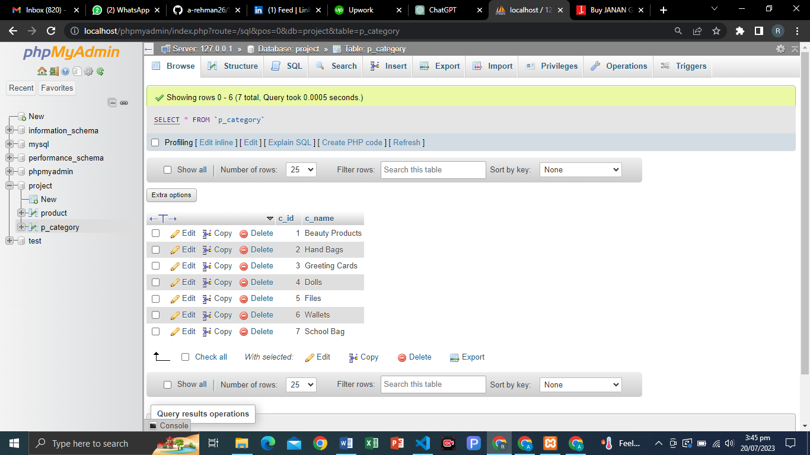

VIEW CATEGORY:

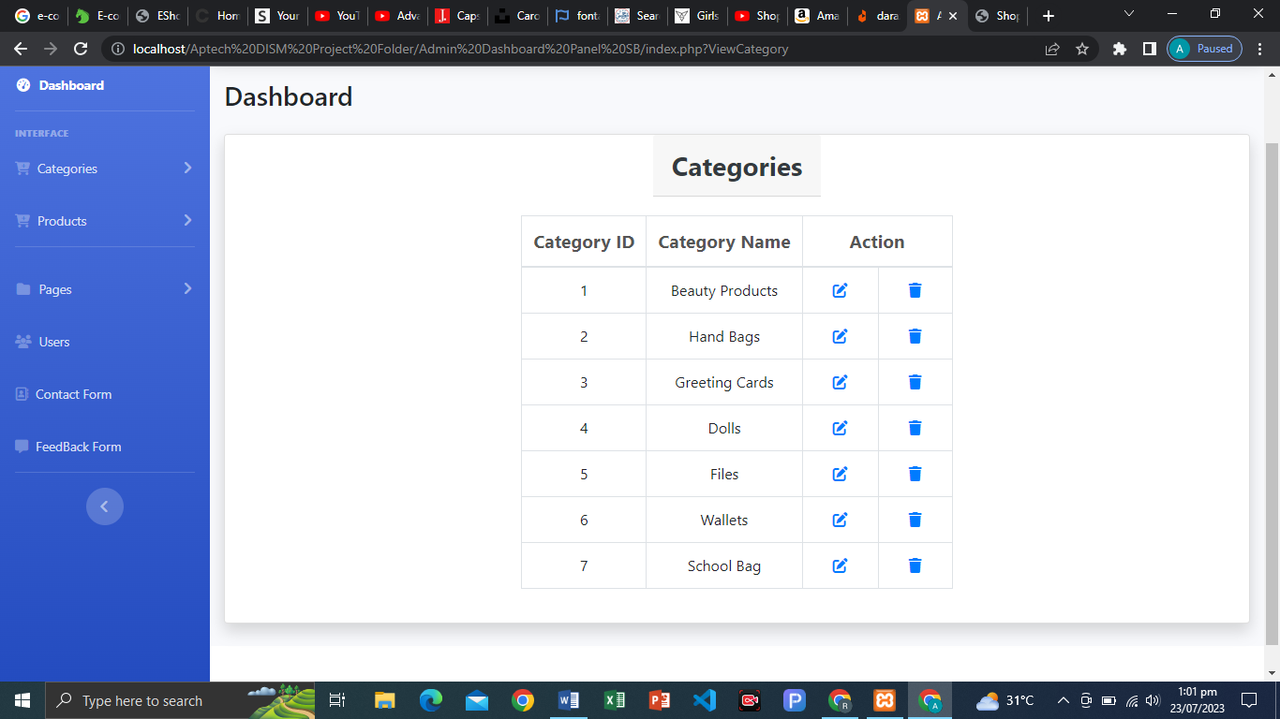

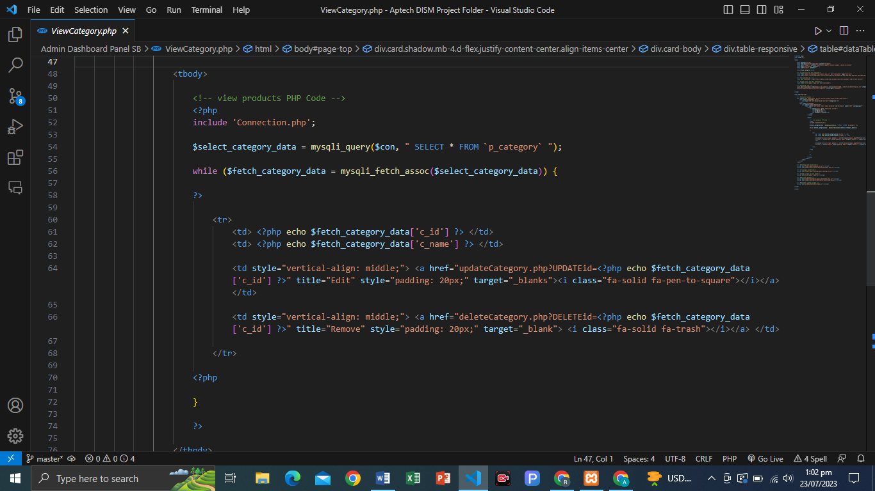PHP CODE (VIEW CATEGORY):

UPDATE CATEGORY:

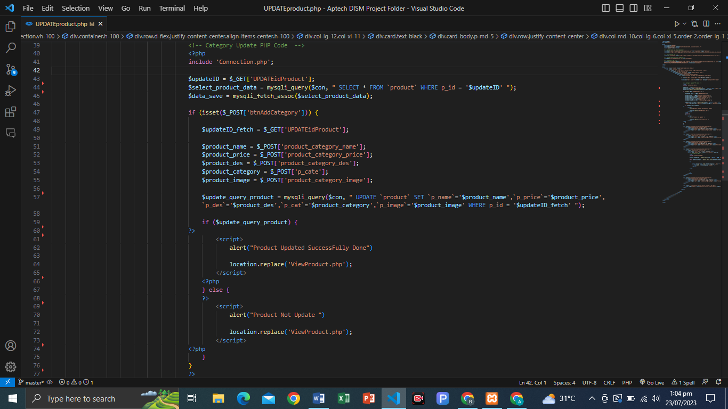

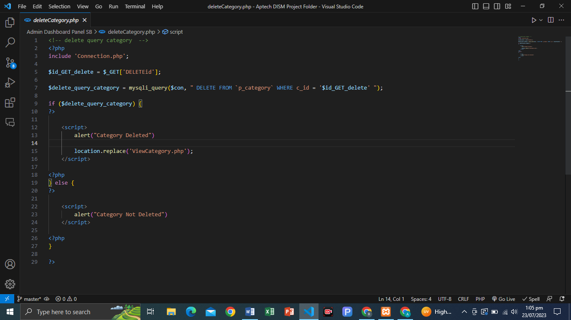DELETE CATEGORY:

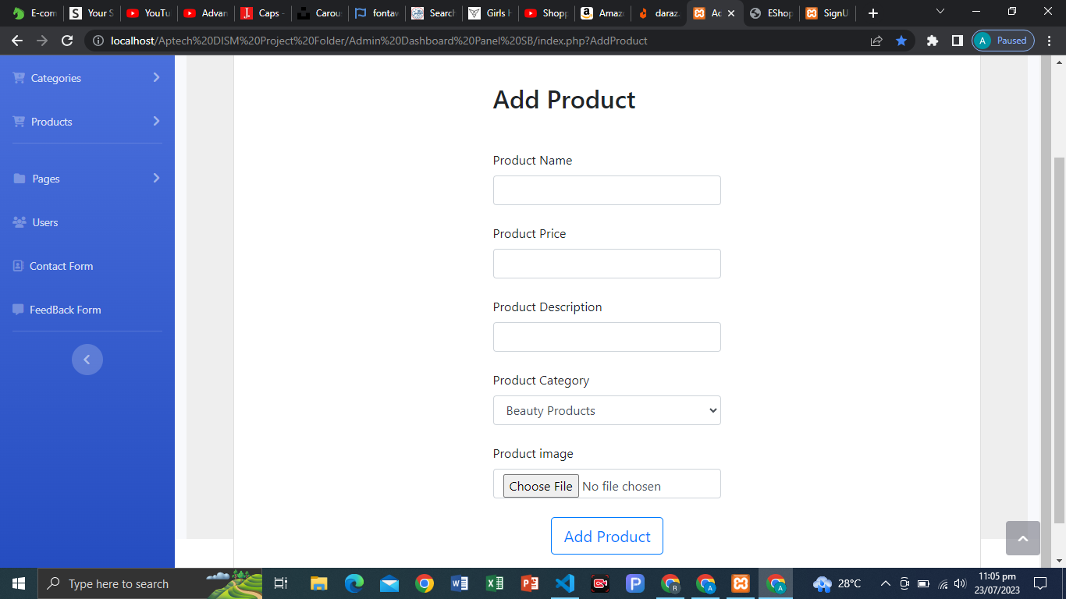 ADD PRODUCT:

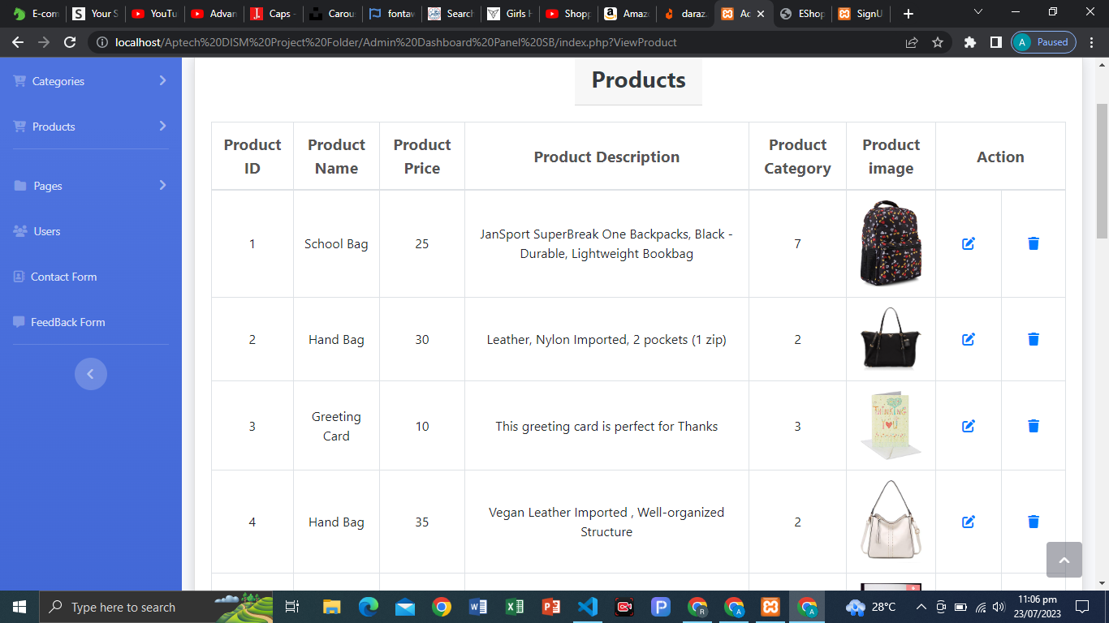VIEW CATEGORY:

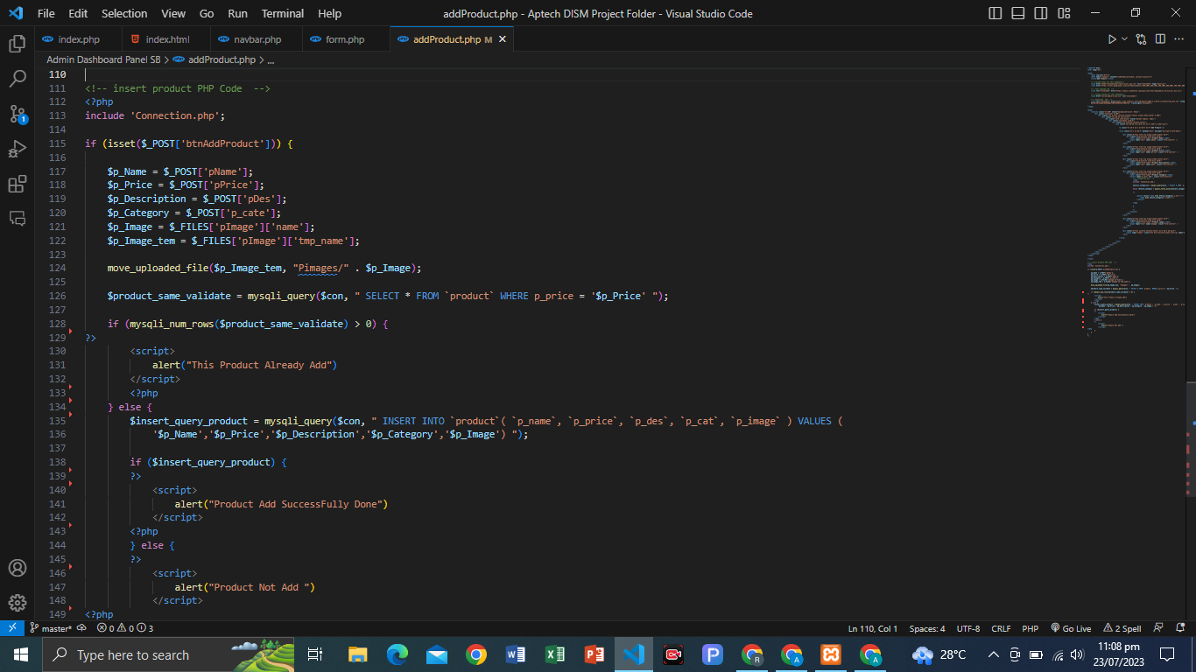ADD PRODUCT PHP CODE:

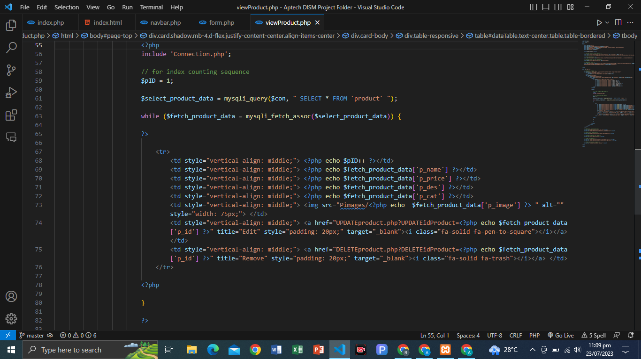VIEW PRODUCT PHP CODE:

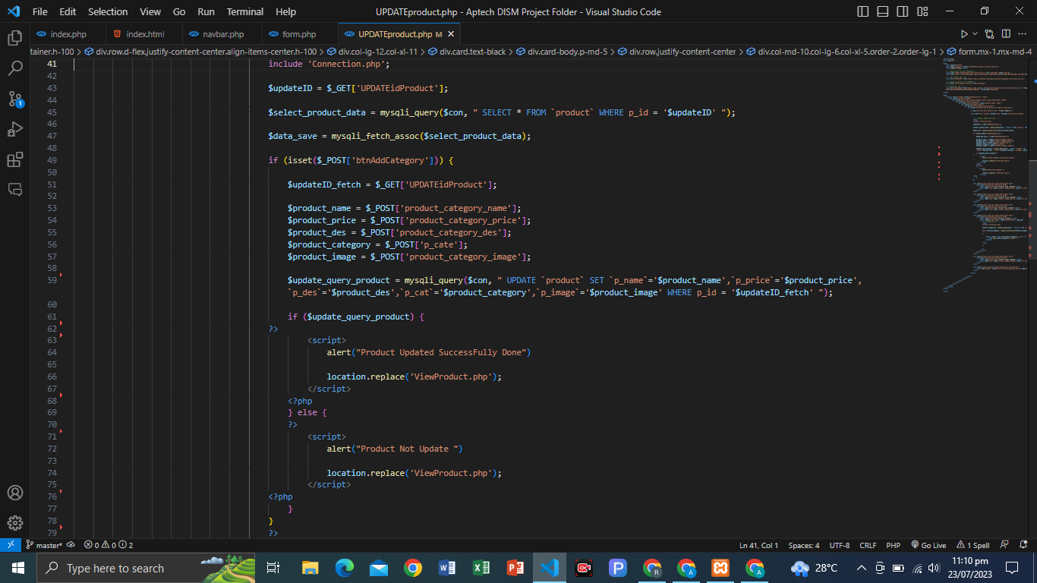PRODUCT UPDATE PHP CODE:

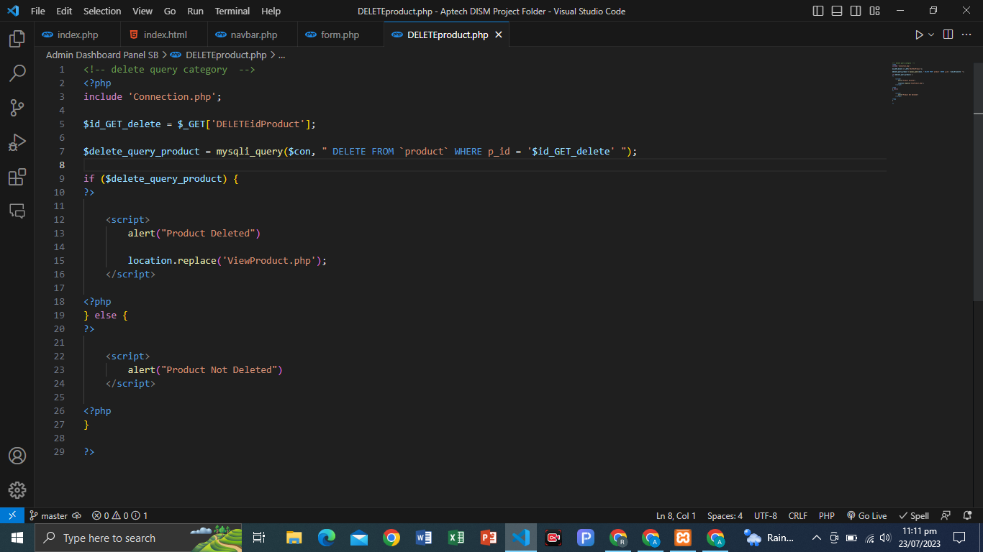DELETE PRODUCT

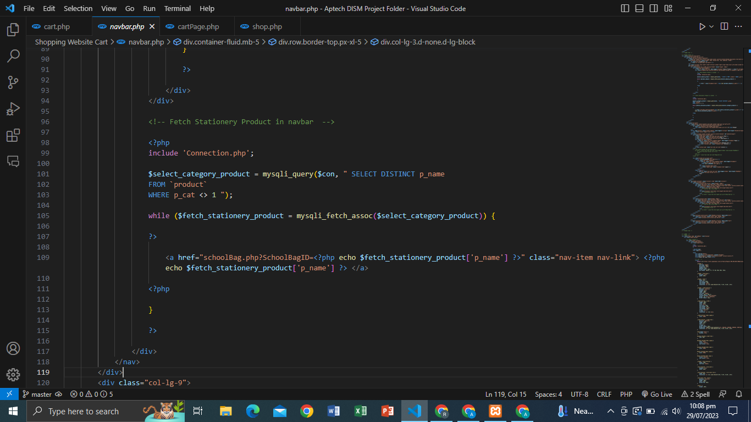**FETCH CATEGORY IN NAVBAR:**

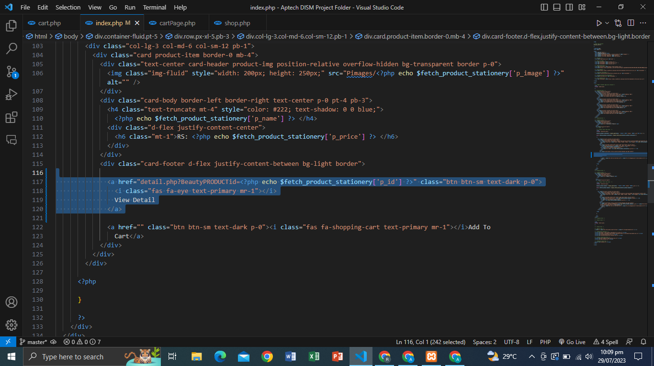**VIEW PRODUCT DETAIL:**

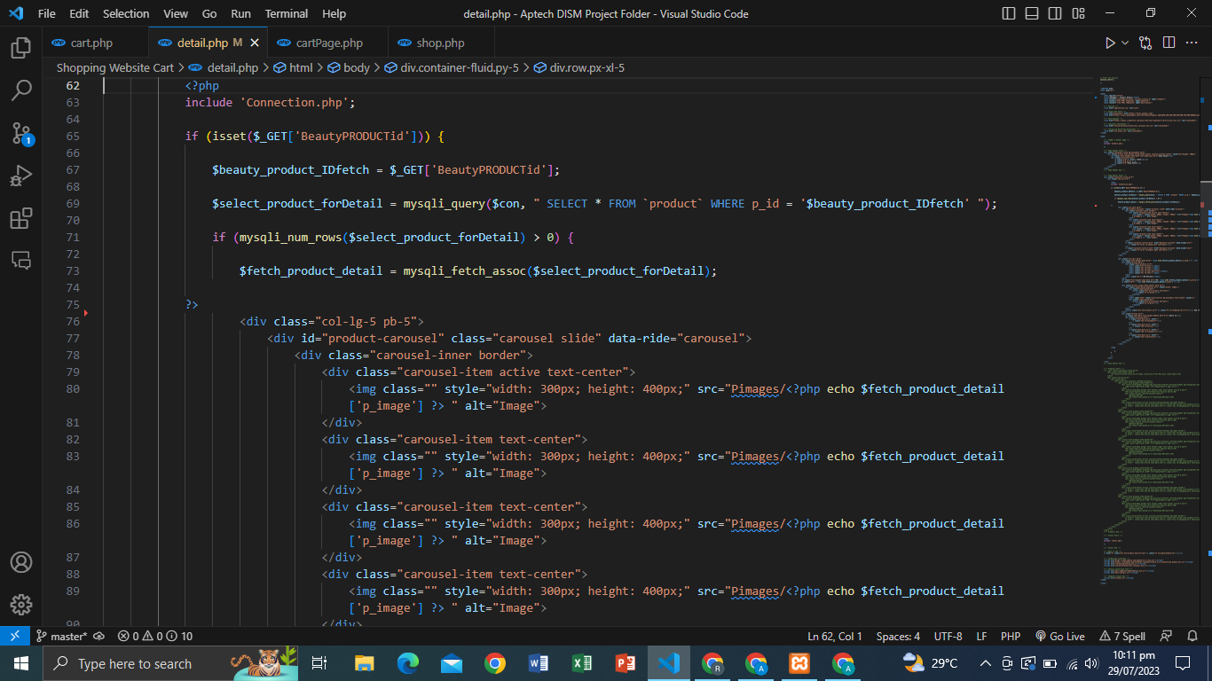**PRODUCT DETAIL FETCH PAGE:**

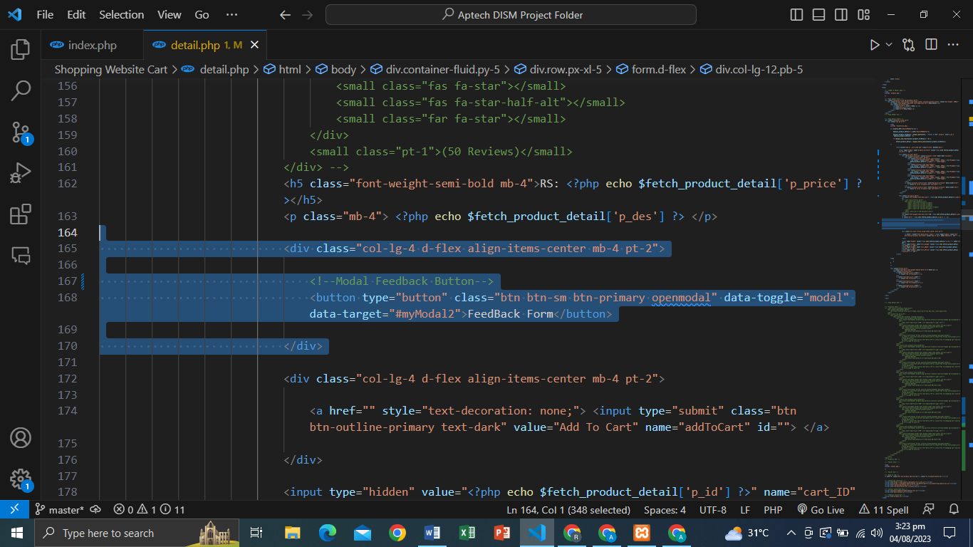PRODUCT FEEDBACK BUTTON**:**

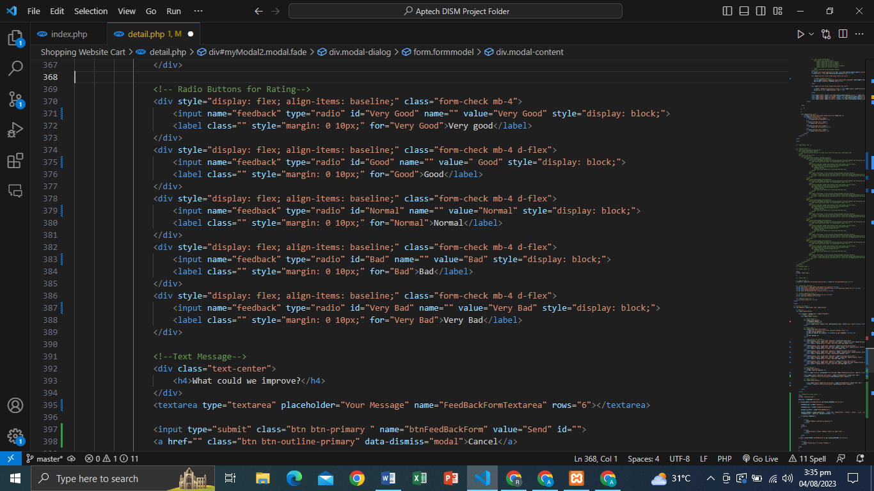**FEEDBACK FORM:**

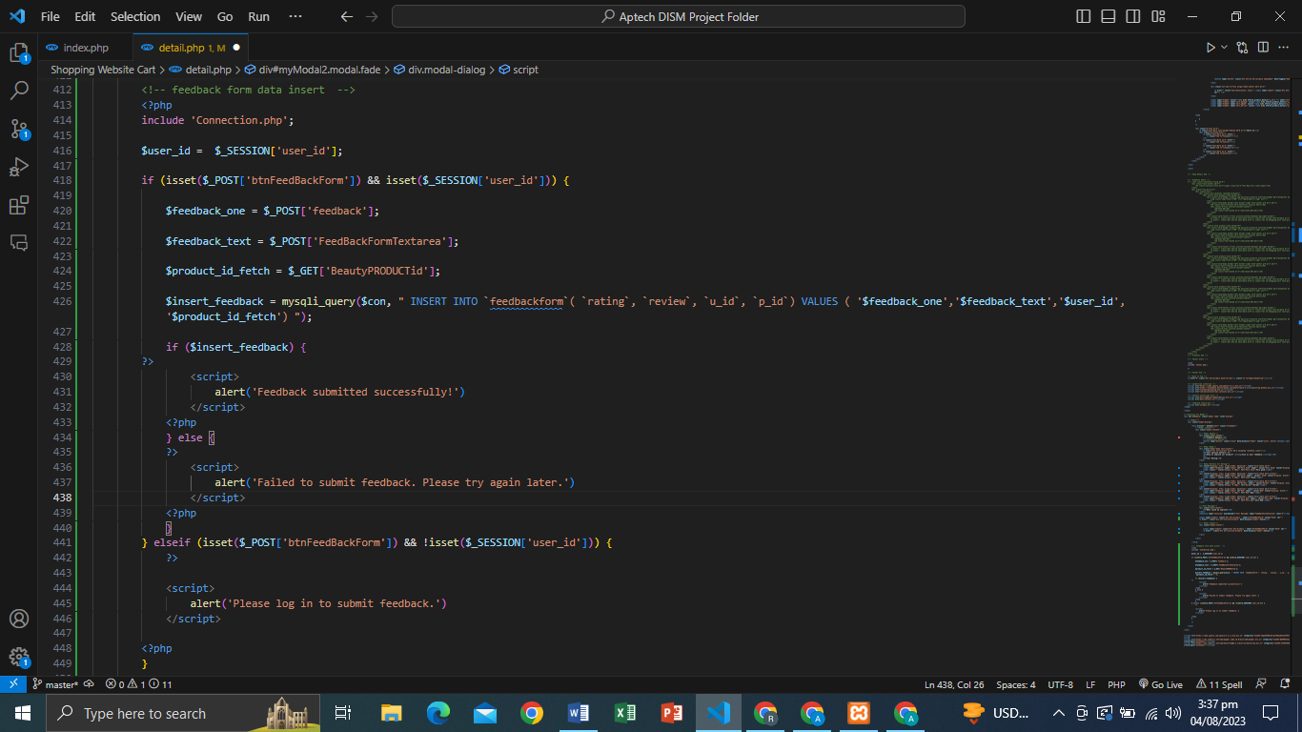**PHP PRODUCT FEEDBACK FORM DATA INSERT CODE:**

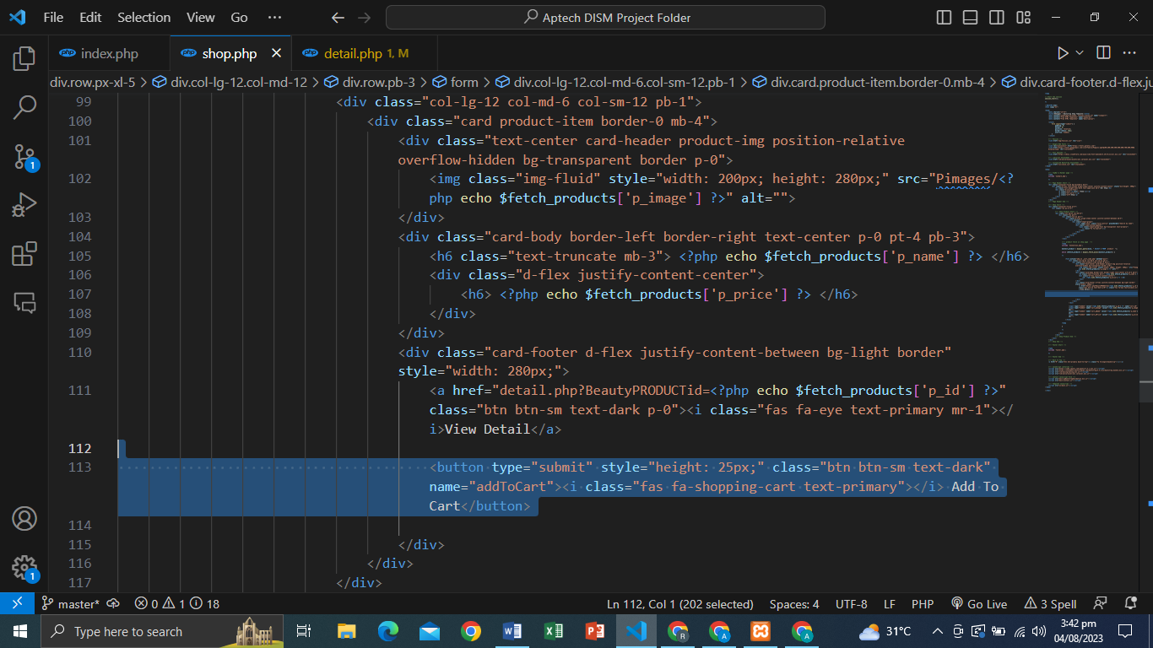**ADD TO CART BUTTON:**

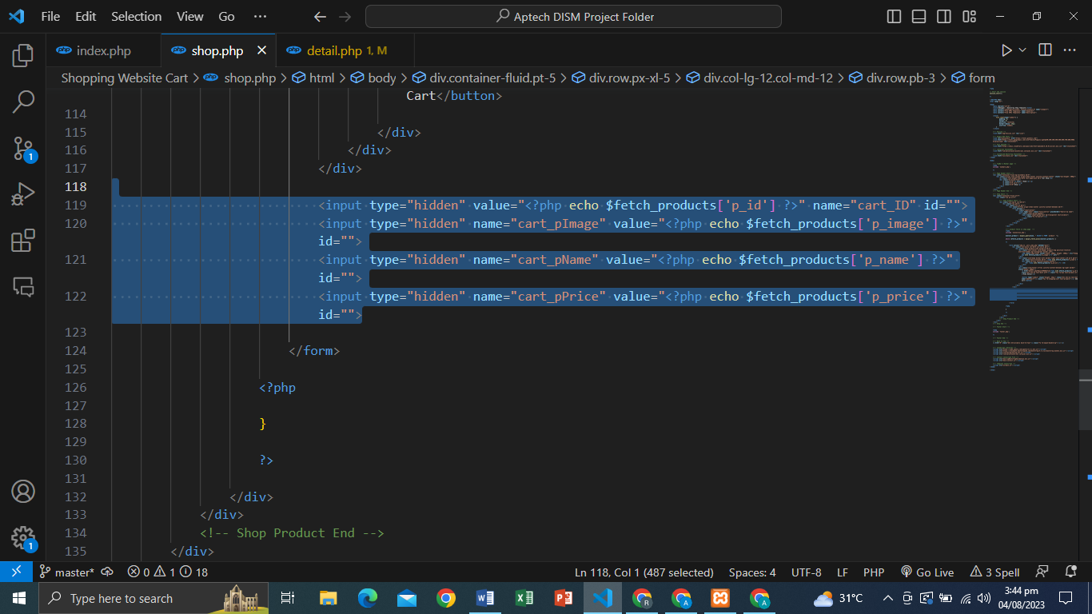**ADD TO CART INPUTS THAT FETCH FOR INSERT CART:**

1. 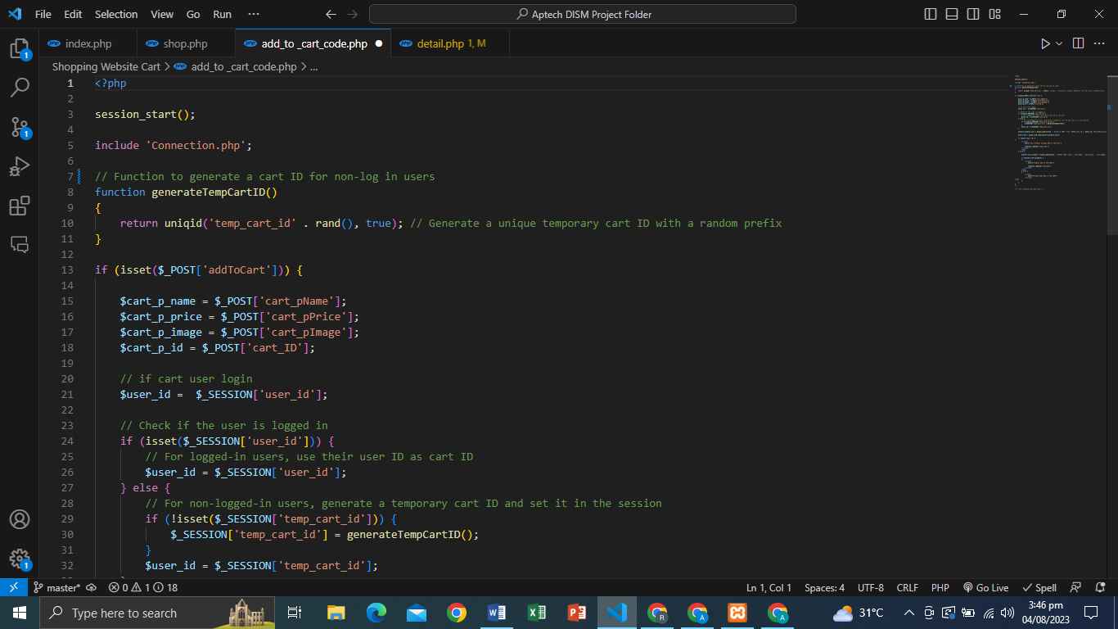**ADD TO CART CODE:**
2. 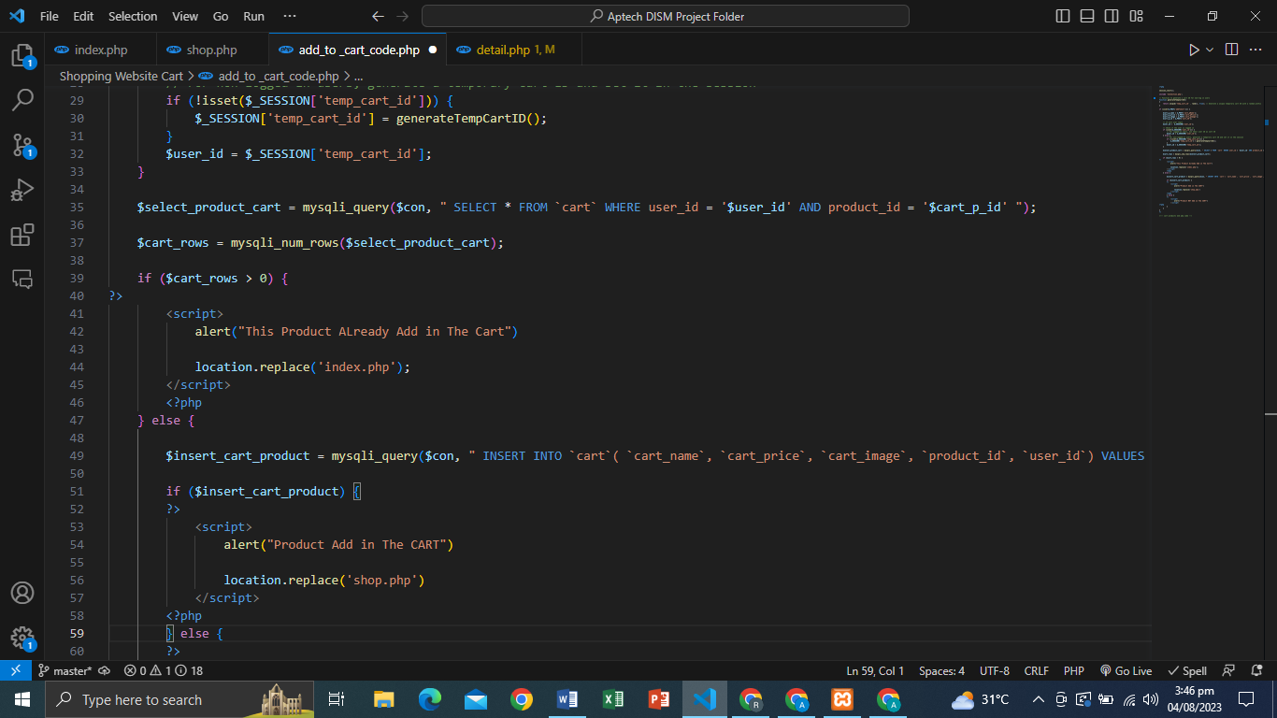**ADD TO CART CODE:**
3. 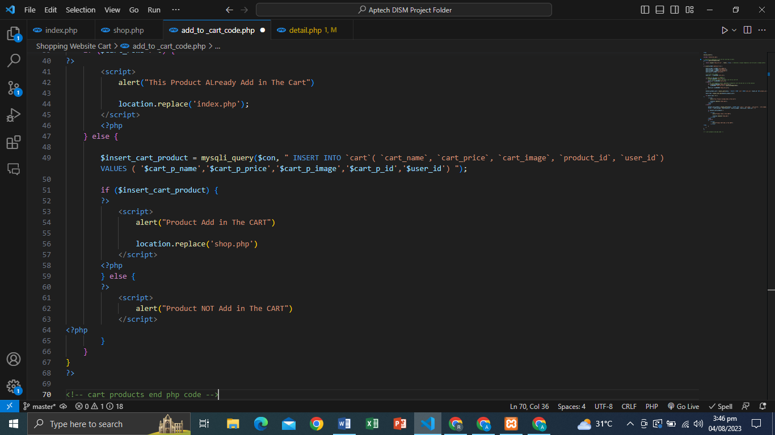**ADD TO CART CODE:**

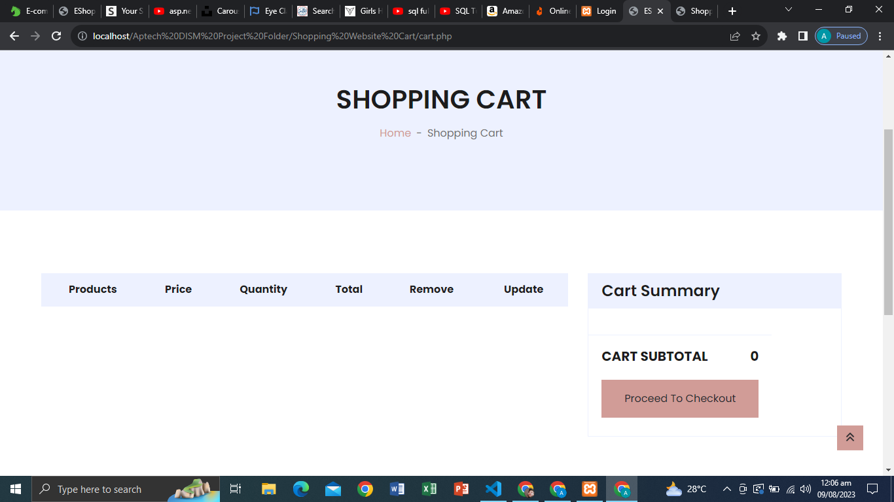CART PAGE WEB PAGE:

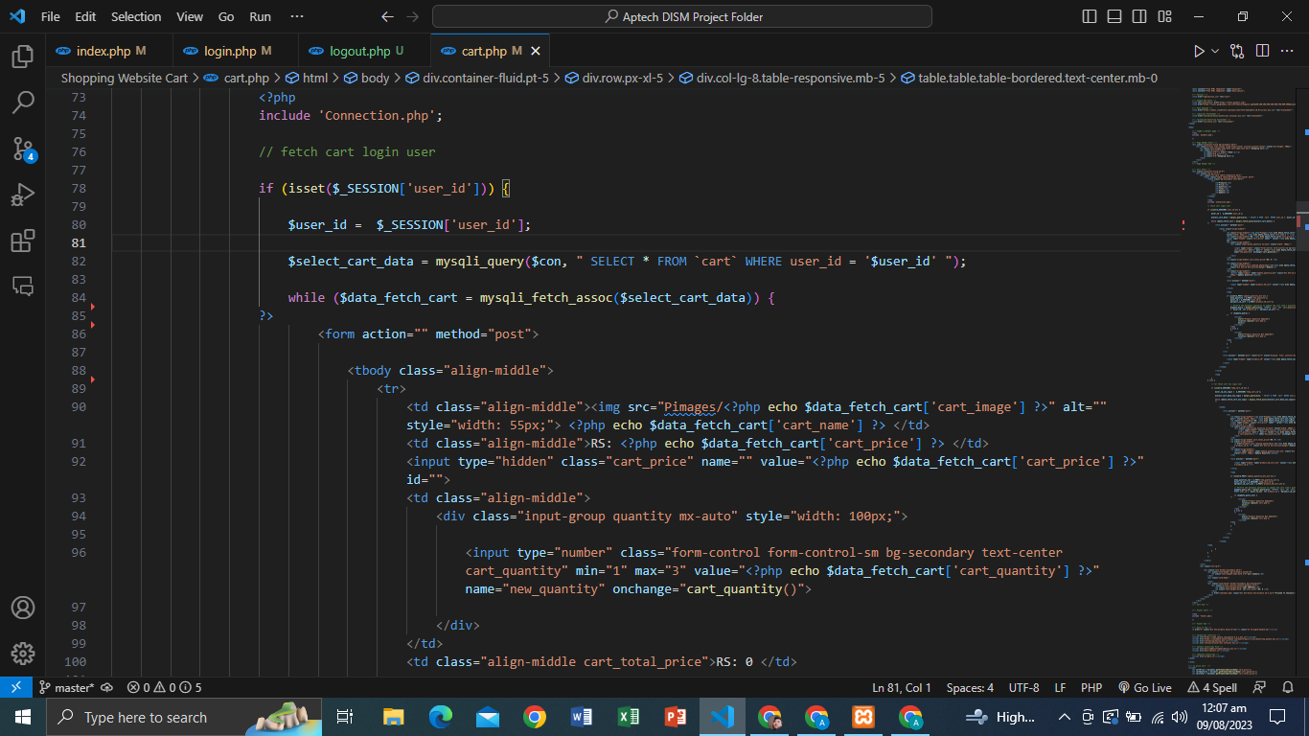CART PAGE PRODUCT FETCH CODE ( 1 ) [ FOR LOGIN USERS ]

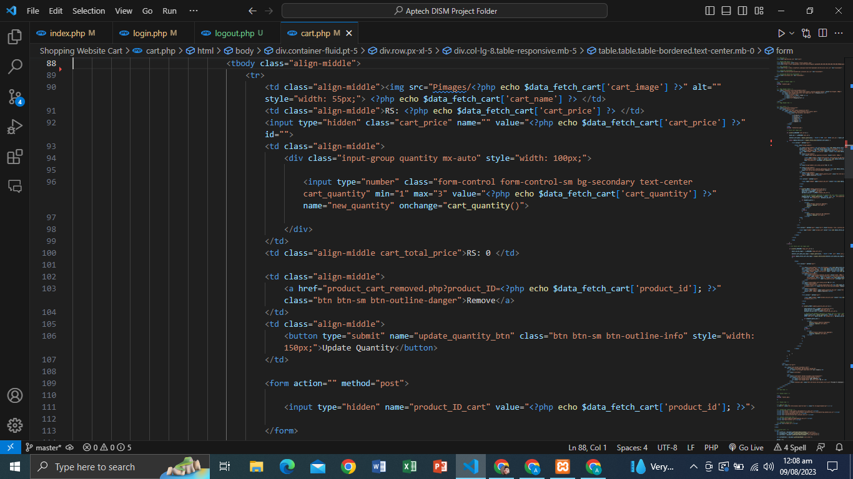**CART PAGE PRODUCT FETCH CODE ( 2 ) [ FOR LOGIN USERS ]**

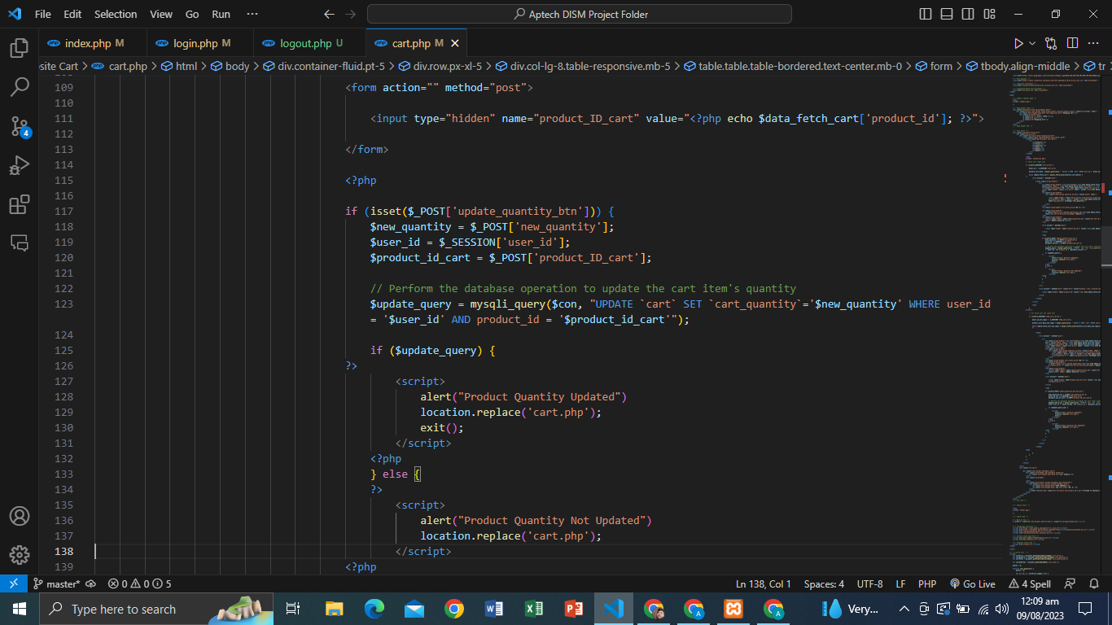**CART PAGE PRODUCT UPDATE QUANTITY CODE ( 1 ) [ FOR LOGIN USERS ]**

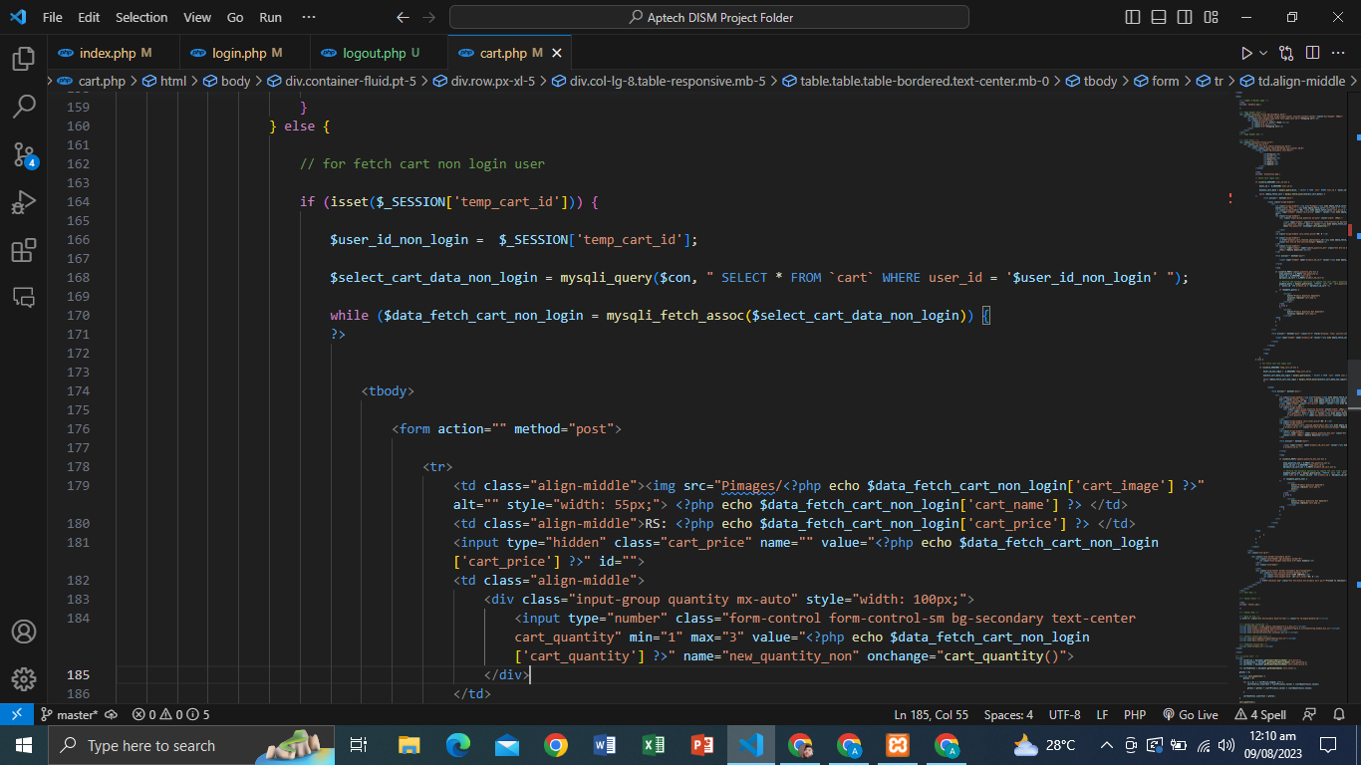**CART PAGE PRODUCT FETCH CODE ( 1 ) [ FOR NON LOGIN USERS ]**

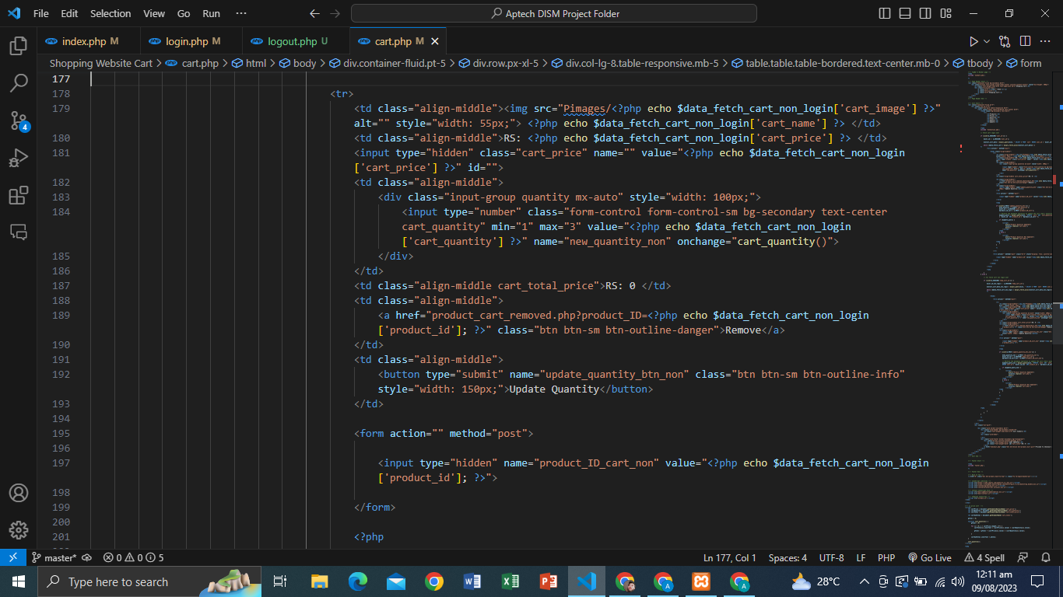**CART PAGE PRODUCT FETCH CODE ( 2 ) [ FOR NON LOGIN USERS ]**

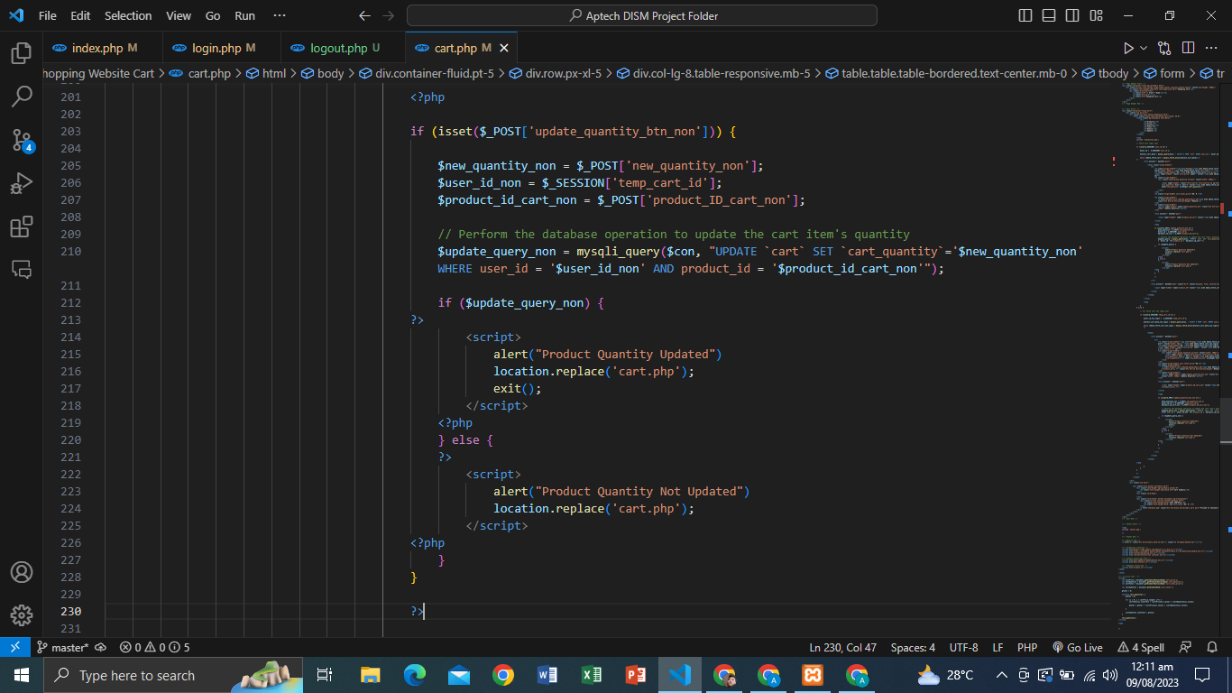**CART PAGE PRODUCT UPDATE QUANTITY CODE ( 1 ) [ FOR NON LOGIN USERS**

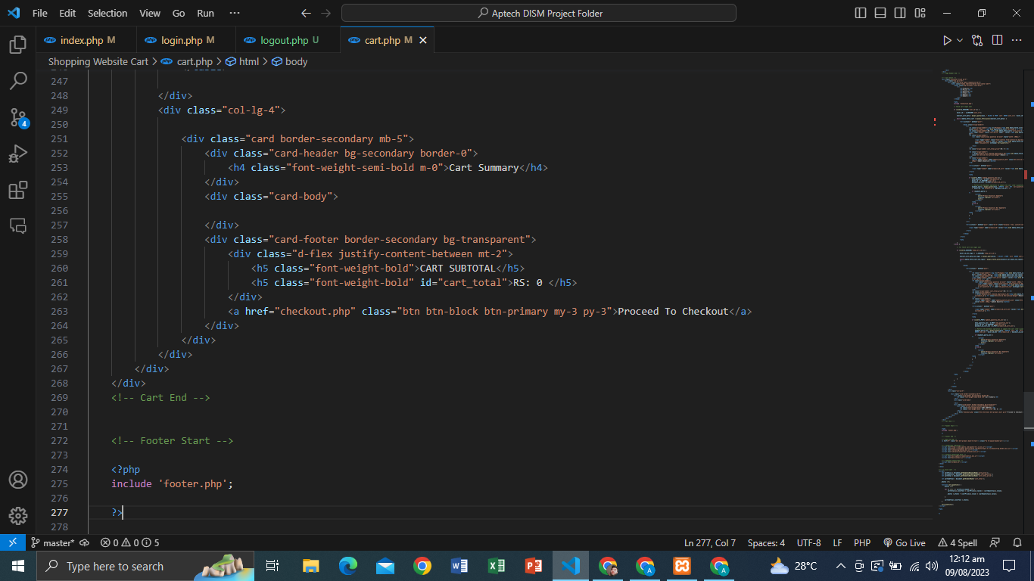**CART PAGE SUMMARY:**

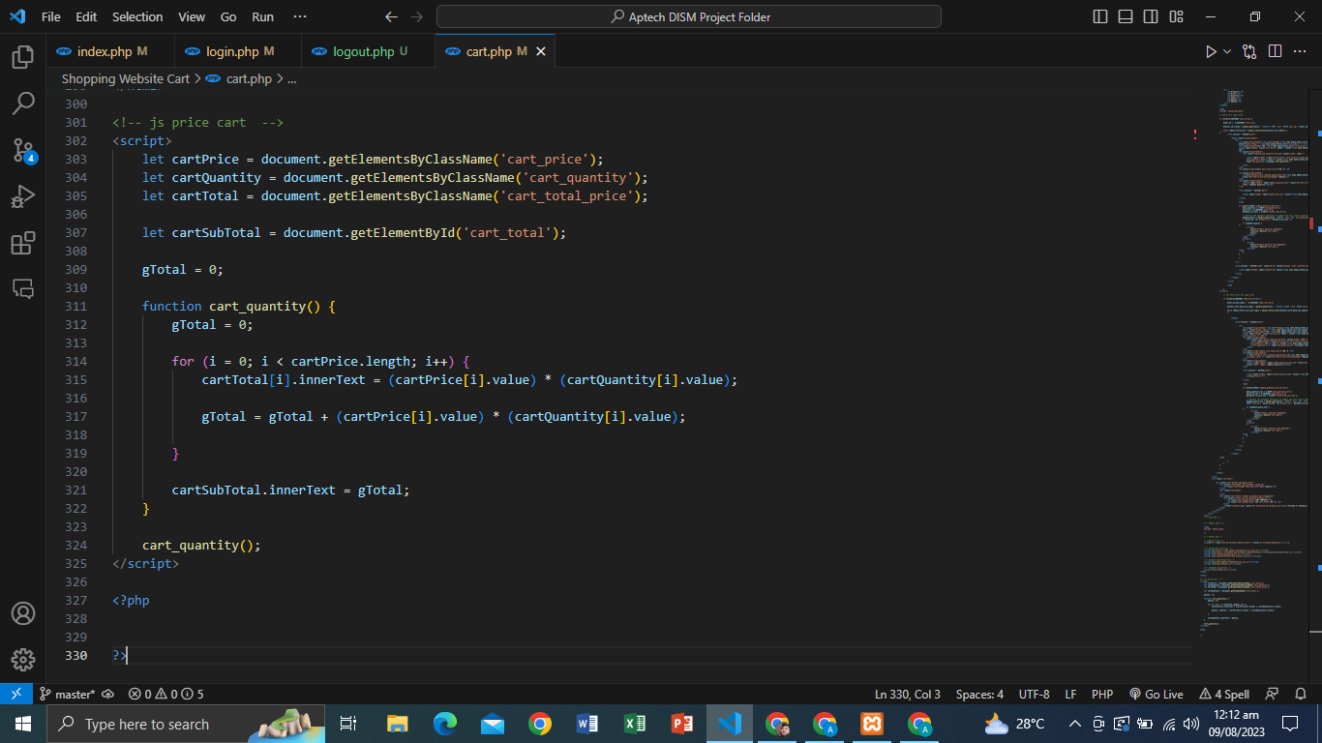**CART PAGE SUMMARY CALCULATION CODE:**

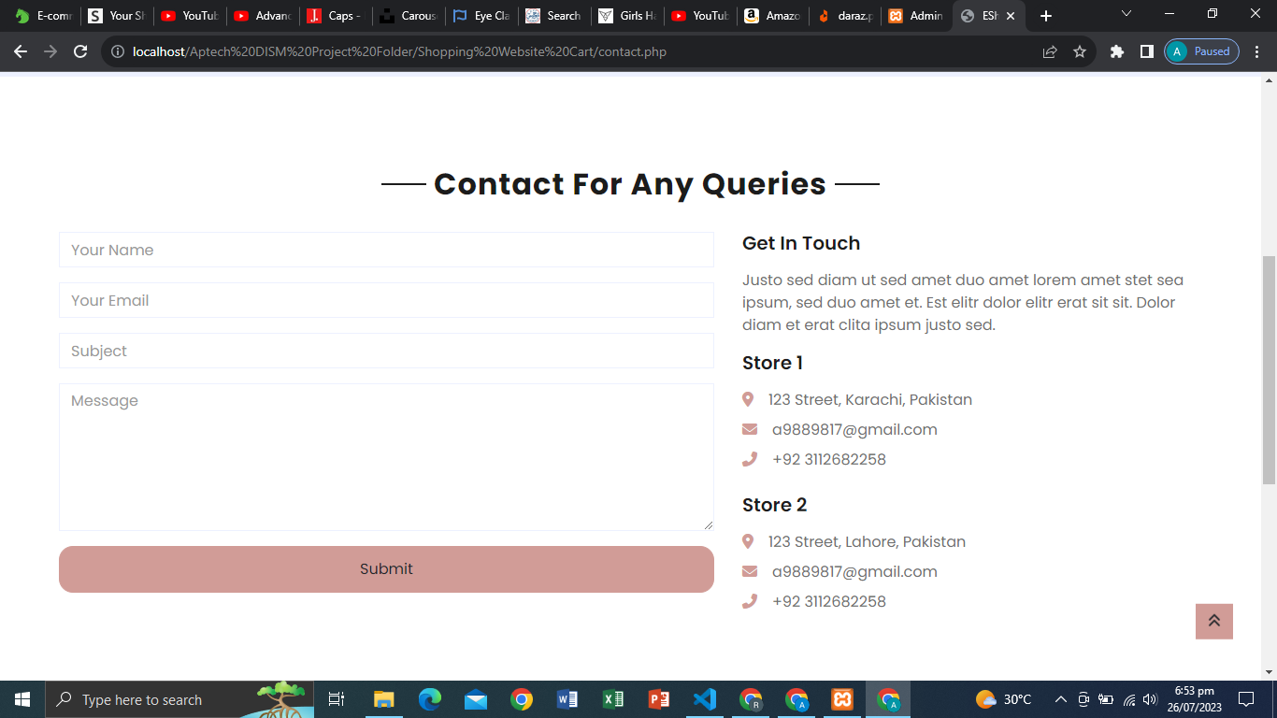**Contact Form:**

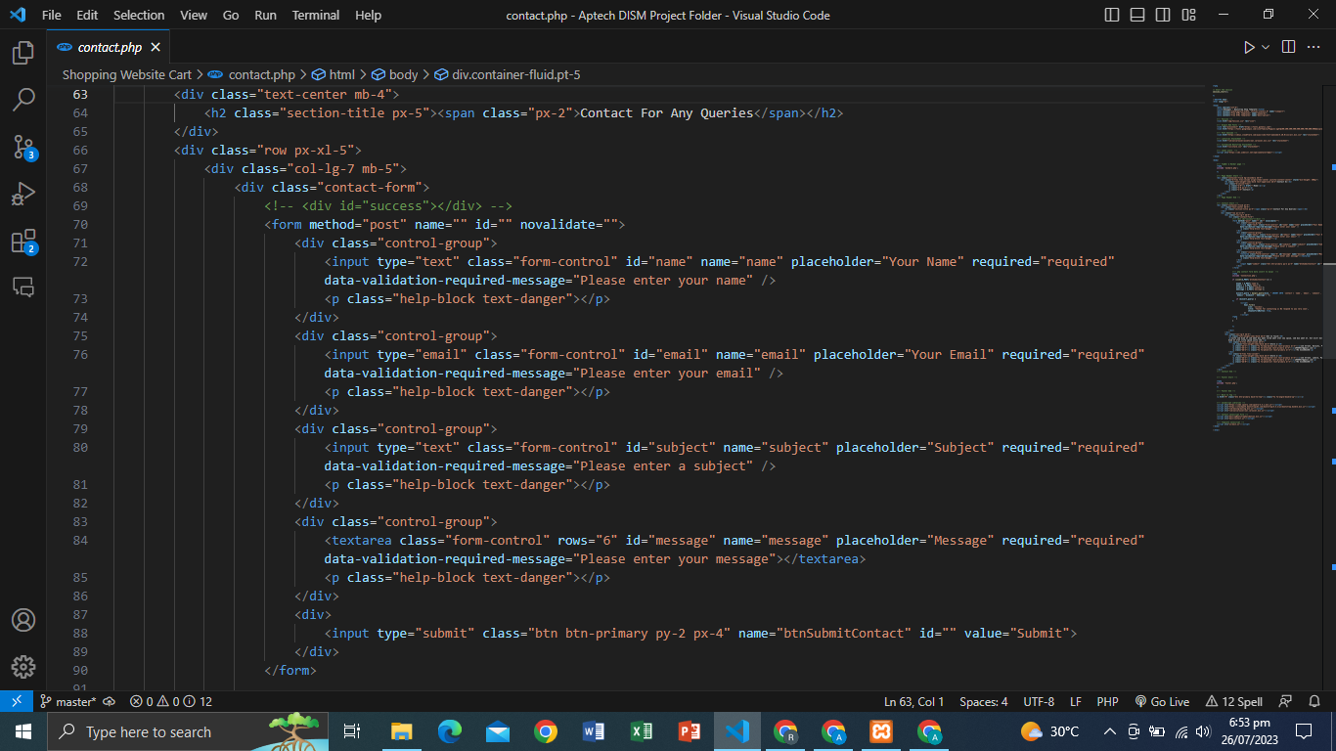**FORM STRUCTURE:**

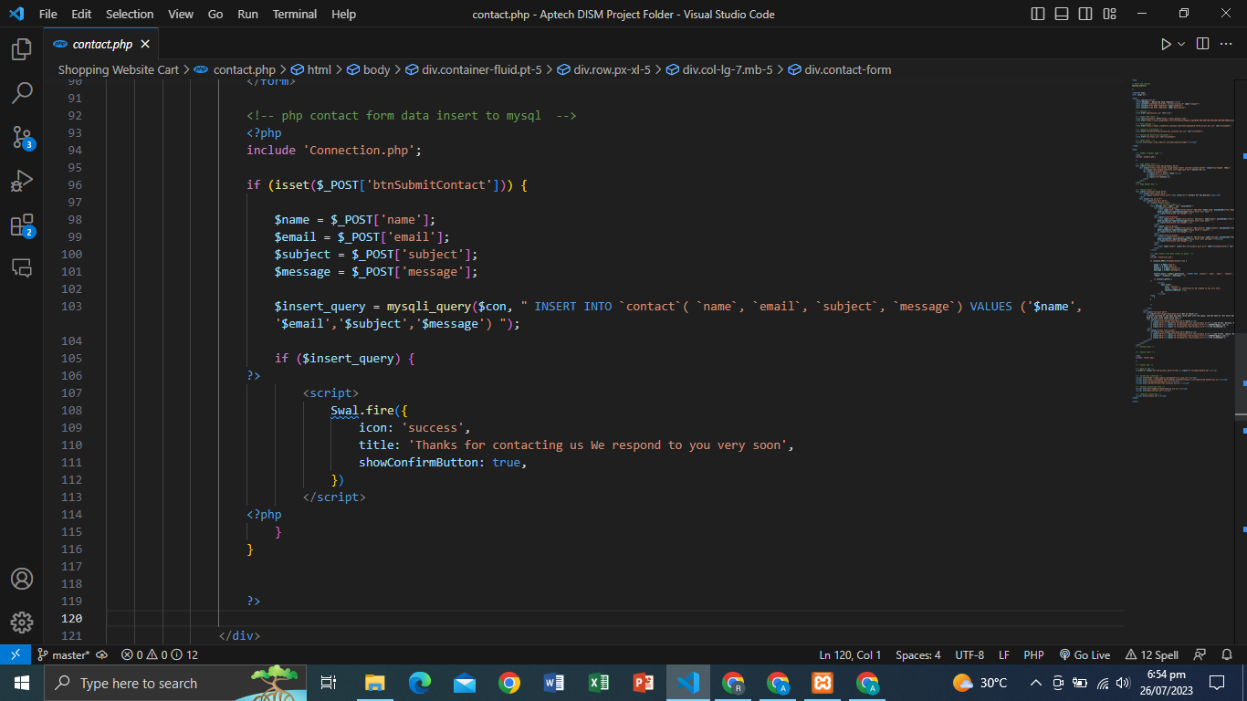**PHP DATA INSERT CONTACT FORM:**

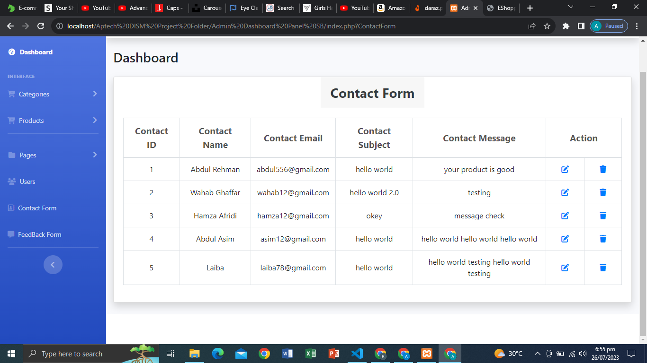**CONTACT DATA VIEW:**

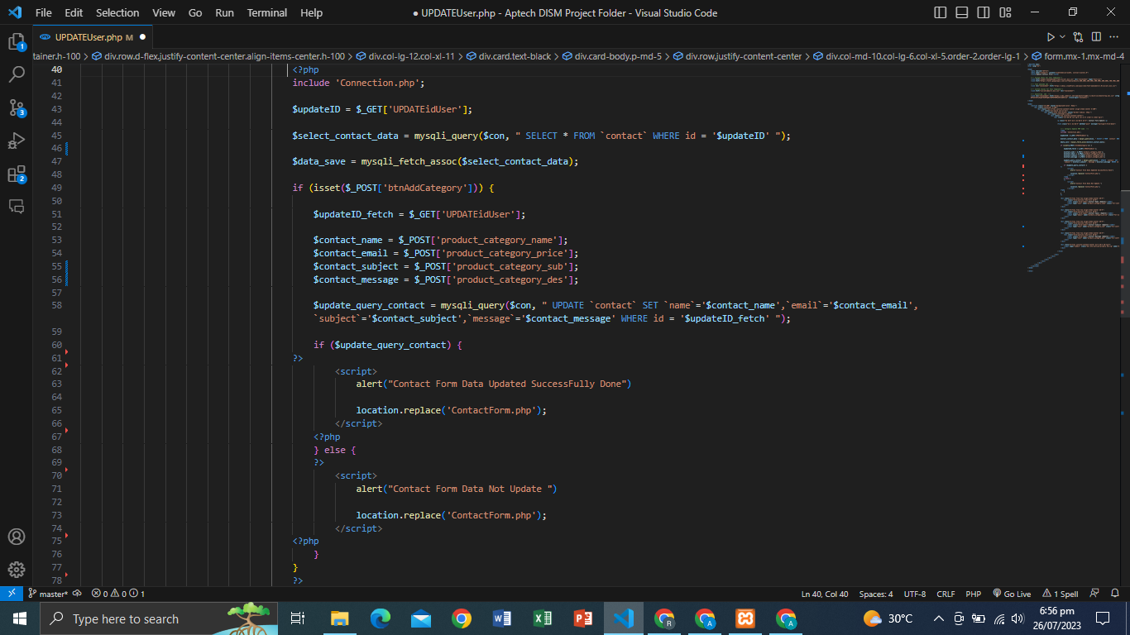**CONTACT DATA UPDATE CODE:**

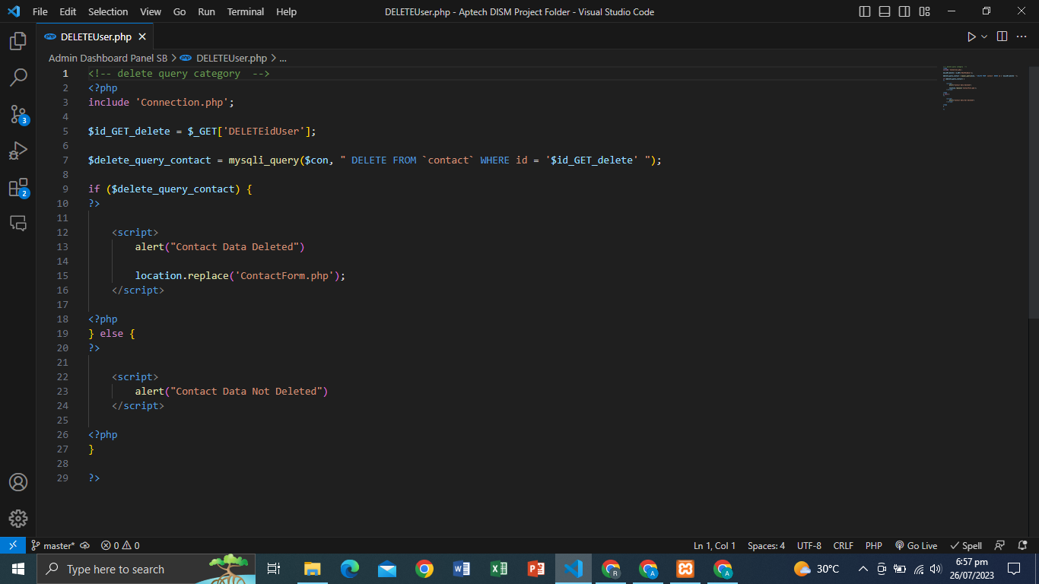**DELETE USER DATA:**

**SIGNUP FORM:**

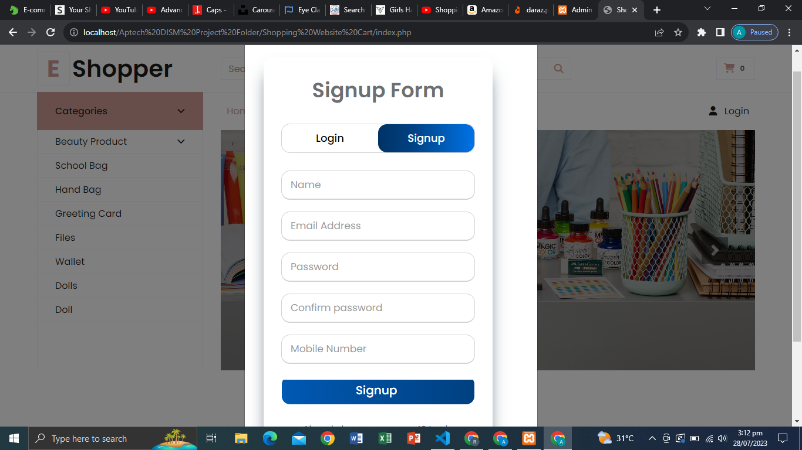

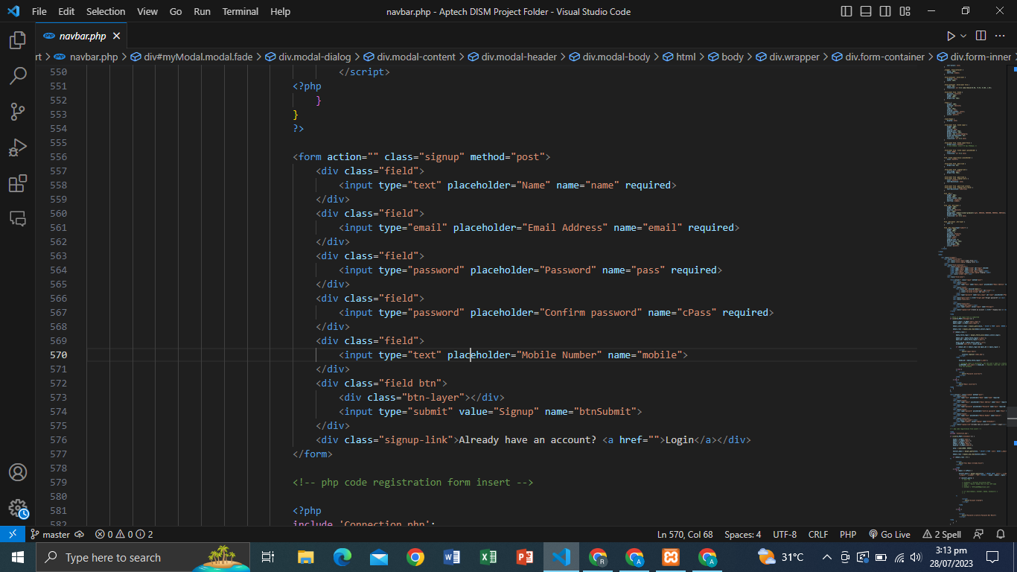**FORM STRUCTURE:**

**FORM INSERT DATA PHP CODE:**

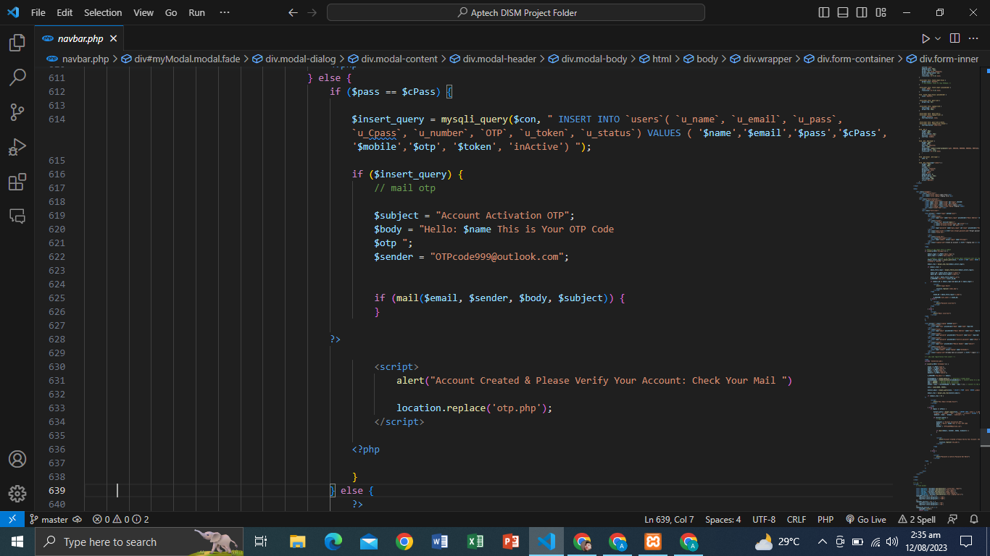

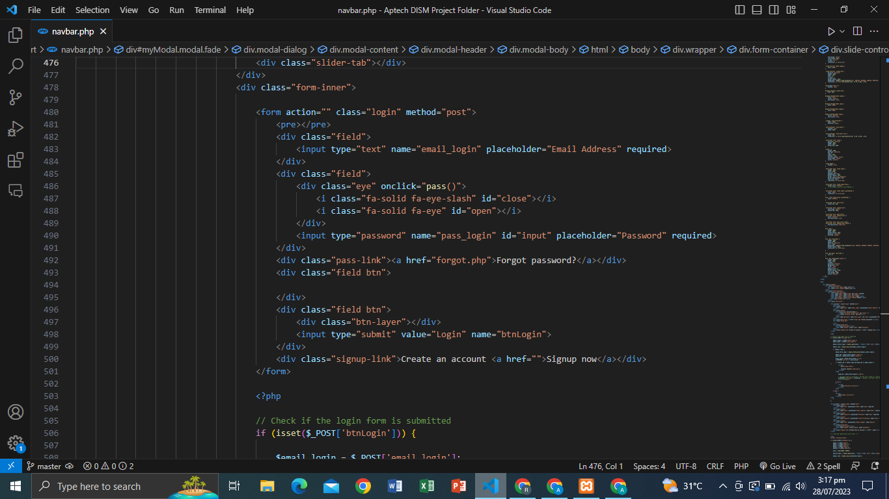**FORM STRUCTURE LOGIN:**

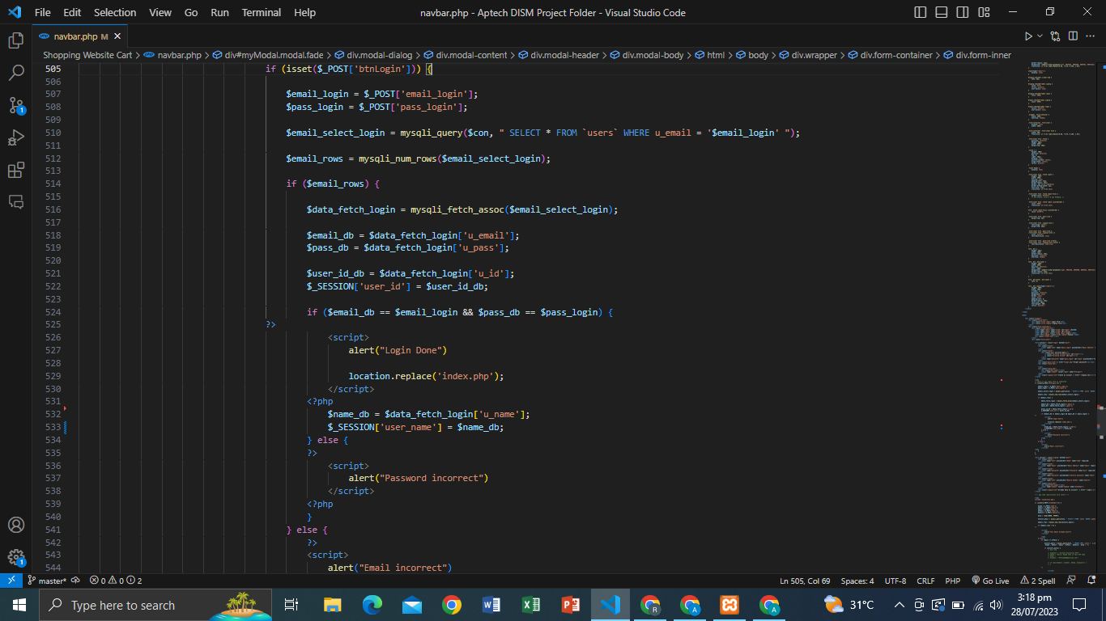**LOGIN FORM PHP CODE:**

**USER FORGOT PASSWORD FORM STRUCTURED**

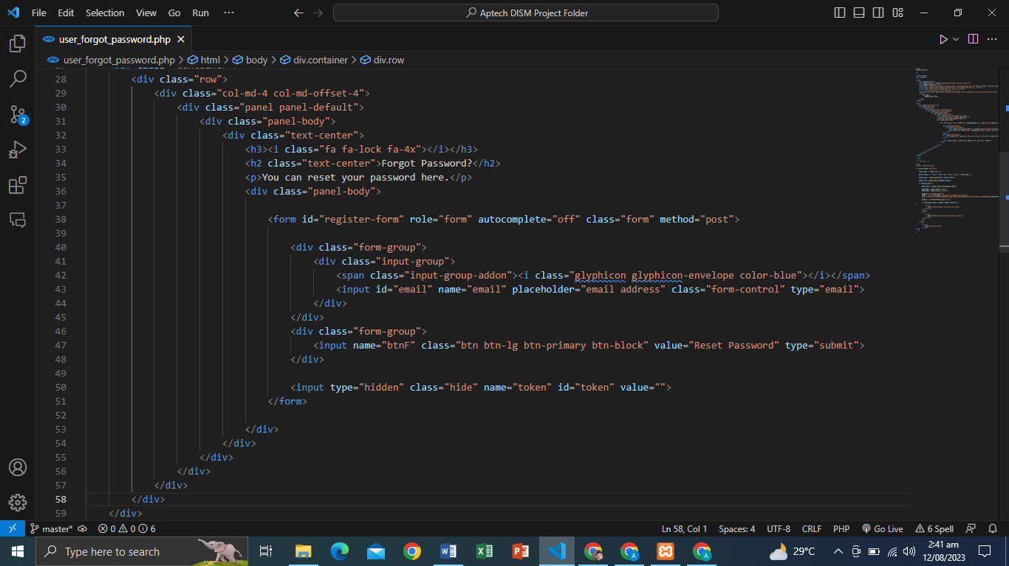

**USER FORGOT PASSWORD CODE ( 1 ) PART:**

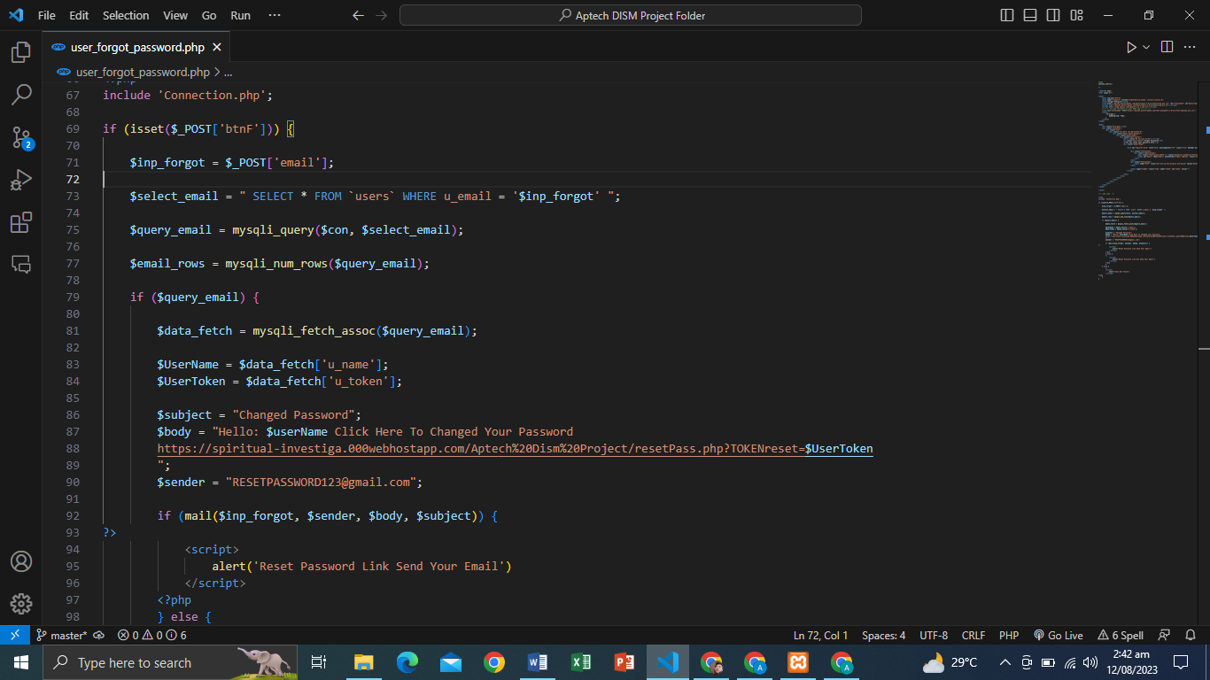

USER FORGOT PASSWORD CODE ( 2 ) PART:

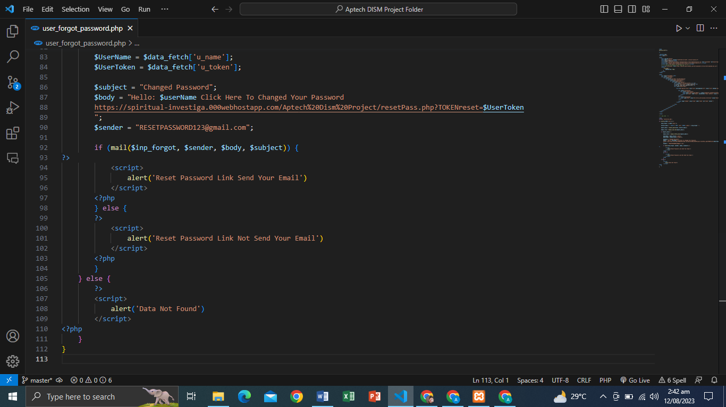

**USER CHANGED PASSWORD:**

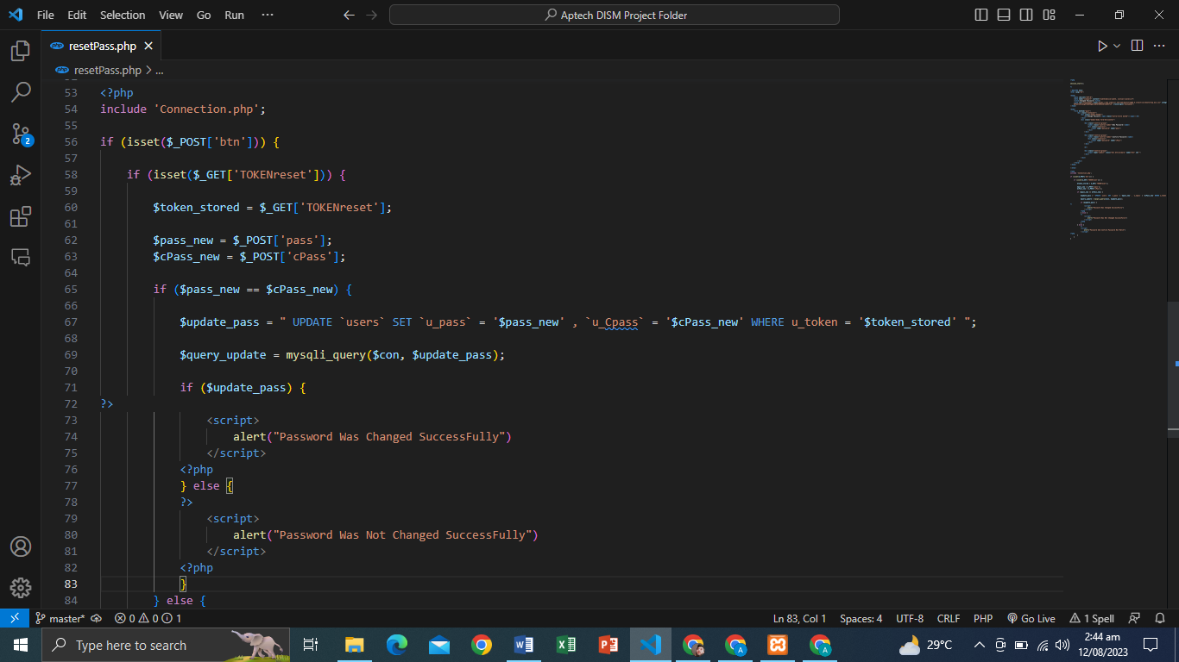

**USER CHANGED PASSWORD CODE ( 1 ) PART:**

